

Tribhuvan University
Faculty of Humanities and Social Sciences

“ONLINE JOB PORTAL”

A PROJECT REPORT

Submitted To Department of Computer Application

Ed-Mark College

In partial fulfillment of the requirements for the Bachelors in Computer Application

Submitted By
Anisha Khatiwada

TU Reg. No: 6-2-727-5-2022

Sima Malla

TU Reg. No: 6-2-727-34-2022

FEBRUARY 2024

Under the Supervision of
Er. Sanjay Kumar Sah



Tribhuvan University

Faculty of Humanities and Social Sciences
Ed-Mark College

SUPERVISOR’S RECOMMENDATION
I hereby recommend that this project prepared under my supervision by Anisha Khatiwada and Sima Malla entitled “Online Job Portal” in partial fulfillment of the requirements for the degree of Computer Application is recommended for the final evaluation.

Project Supervisor
Er. Sanjay Kumar Sah
Department of Bachelor in Computer Application
Ed-Mark College
Kalanki, Kathmandu



Tribhuvan University
Faculty of Humanities and Social Science
Ed-Mark College

LETTER OF APPROVAL
This is to certify that this project is prepared by Anisha Khatiwada and Sima Malla entitled “Online Job Portal” in partial fulfillment of the requirements for the degree of Bachelor in Computer Application has been evaluated. In our opinion it is satisfactory in the scope and quality as a project for the required degree.

…………………………  Er. Sanjay Kumar Sah  Supervisor  Department of Bachelors in Computer Application  Ed-Mark College  Kalanki, Kathmandu | …………………………  Er. Sanjay Kumar Sah  Coordinator  Department of Bachelors in Computer Application  Ed-Mark College  Kalanki, Kathmandu
……………………….  Internal Examiner | ………………….……  External Examiner

ACKNOWLEDGEMENT
We would like to express our sincere gratitude to all those who have contributed to the successful completion of this project, “Online Job Portal”. Their support, guidance, and encouragement have been invaluable throughout this journey.

First and foremost, we extend our heartfelt appreciation to my supervisor, Mr. Sanjay Kumar Sah. His support, valuable insights, and continuous motivation. Their expertise and guidance have played a pivotal role in shaping this project and ensuring its success.

Lastly, we would like to acknowledge the unwavering support and understanding of our family, who have been my pillars of strength throughout this endeavor. There encouragement and belief in our abilities have been constant source of motivation.

We sincerely appreciate the collective efforts and contributions of all those involved, as this project would not have been possible without their support. We are grateful for the knowledge and experience gained, and we look forward to the positive impact that “Online Job Portal” will have on the college for the students who want to do part time job along with their studies.

Sincerely,
Anisha Khatiwada
Sima Malla

ABSRTACT
The proposed online job portal system offers various features and services to its members, including job information, online job application submission, and other related facilities. The system aims to provide job seekers with a platform to search for employment opportunities conveniently. Additionally, the job portal enables employers to establish direct connections with potential candidates. The main focus of this portal is to facilitate the posting and management of job vacancies. All job openings will be made available online, allowing employers to easily post their vacancies on the platform. The system is designed to streamline the review and management of job applications through the web interface, ensuring efficient handling of the entire recruitment process. Moreover, employers can quickly find resumes that match their required skill sets, saving time in the hiring process.

Keywords: Job Seekers, employment opportunities, resumes, hiring process, management of job.

TABLE OF CONTENTS
ACKNOWLEDGMENT........................................................................................................i ABSTRACT...........................................................................................................................ii
TABLE OF CONTENTS......................................................................................................iii
LIST OF Figure.....................................................................................................................iv
LIST OF TABLE .................................................................................................................v
LIST OF ABBRIVIATIONS................................................................................................vi
CHAPTER 1 INTRODUCTION ..........................................................................................1
1.1 Introduction .....................................................................................................................1
1.2 Problem Statement ..........................................................................................................2
1.3 Objectives.........................................................................................................................2
1.4 Scope and Limitations.......................................................................................................3
1.5 Report Organization .........................................................................................................3
CHAPTER 2 BACKGROUND OF STUDY AND LITERATURE REVIEW.......................4
2.1 Background of Study......................................................................................................4
2.1 Literature Review...........................................................................................................4
CHAPTER 3 SYSTEM ANALYSIS AND DESIGN ...........................................................6
3.1 System Analysis...............................................................................................................6
3.1.1 Requirement Analysis...................................................................................................7
3.1.2 Feasibility Analysis ......................................................................................................9
3.1.3 Data Modeling (ER-Diagram)........................................................................................10
3.1.4 Process Modeling (DFD)..............................................................................................11
3.2 System Design................................................................................................................12
3.2.1 Architecture Design.....................................................................................................13
3.2.2 Database Schema Design............................................................................................14
3.2.3 Interface Design..........................................................................................................14
3.2.4 Physical DFD…………………………………………………………………………..16
CHAPTER 4 IMPLEMENTATION AND TESTING………………………………...…….17
4.1 Implementation..................................................................................................................17
4.1.1 Tools Used (CASE tools, Programming languages, Database platforms) .....................17
4.1.2 Implementation Details of Modules..........................................................................18
4.2 Testing....................................................................................................................19
4.2.1 User Registration Testing ...................................................................................19
4.2.2 User Login Testing .............................................................................................19
CHAPTER 5 CONCLUSION AND FUTURE RECOMMENDATIONS……...….20
5.1 Lesson learnt/Outcome............................................................................................20
5.2 Conclusion................................................................................................................20
5.3 Future Recommendations.........................................................................................20
References.....................................................................................................................21
Appendices…………………………………………………………………………………….
LIST OF FIGURES
Figure3.1 Waterfall Model of Online Job Portal……………………………………………6
Figure3. 2Use case diagram of Online Job Portal.................................................................8
Figure3. 3Gant Chart of Online Job Portal...........................................................................10
Figure3. 4E-R Diagram of Online Job Portal.......................................................................10
Figure3. 5Context Level DFD Diagram of Online Job Portal..............................................11
Figure3. 6 Level One DFD Diagram of Online Job Portal...................................................12
Figure3. 7 Flow Chart Diagram of Online Job Portal...........................................................13
Figure3. 8 Database Schema Design of Online Job Portal...................................................14
Figure3.9 Employer/User Login Page………………………………………………………15
Figure3.10 Job Category Page………………………………………………………………15
Figure3.11 Job Search Page…………………………………………………………………16

LIST OF ABBRIVIATIONS

CASE | Computer Aided Software Engineering
CSS | Cascading Style Sheet
DFD | Data Flow Diagram
ER | Entity Relationship
HTML | Hyper Text Markup Language
JS | JavaScript
MySQL | My Structured Query Language
OS | Operating System
PHP | Hypertext Pre-Processor
RDBMS | Relational Database Management System
UI | User Interface

CHAPTER 1
INTRODUCTION

- Introduction
Job Portal is a web application, which serves job seekers to find available job vacancies and Employers to identify eligible job seekers with the prospect of selecting the most qualified candidates. Job search portals best serve this purpose. E-recruitment has become the standard means for employers and job seekers to meet their respective objectives. The traditional methods for recruitment include Job fairs, Employee referrals, advertising in the newspapers, television, etc.

Online job portals use the internet as a platform for job advertisements, posting of job vacancies, and job applications by job seekers. Job Portal allows Job seekers to apply for a job online by viewing jobs posted by companies. It allows online job posting for companies and sending interview letters to selected candidates by email. Quick and advanced search facility for both Job seekers and Companies is the main advantage of this application. [1]

In order to access this application both the employee and the employer need to register through the use of a username, email, password, and other necessary details after verification by the admin of the website. Above all this the admin of the website has full power over the website and also the job seekers as well as the employers (companies).

Job sites are one of the sources through which job seekers search for jobs. The major activities that are carried out through the online mode for the job search are automated easily through the use of this website without any difficulty. The NepJobs script website helps in accomplishing this task. The reliability of this website can be more without any difficulty. Job seekers can update their resumes with great ease and without any difficulty. [2]

This job portal involves a user (job seeker) creating an account by registering and uploading his/her curriculum vitae. The company(s) also register and publish the job vacancies and job requirements on the portal. The candidate can then apply for the job and the company will vet the applications upon which the candidate can be recruited or turned down. A candidate will be able to access career guidance or advice that will be available in the portal.

- Problem Statement
With the high number of youths in Nepal, landing a job has become a greater challenge. This is greatly contributed by the fact that there is no proper interaction between the job seekers and the companies themselves. There is therefore a concern to design an online recruitment system that allows employers to post their job advertisements, which seekers can refer to when looking for jobs. This job portal is able to capture job requirements based on industry need seekers can refer to when looking for jobs. This job portal is able to capture job requirements based on industry needs.
Some problems of traditional recruitment processes are:
- No proper interaction between the job seekers and the companies
themselves.
- Employers are facing challenges in attracting and identifying qualified candidates.
- Time-consuming, costly, and lacks the tools to accurately assess candidate fit.
- Leading to poor hiring decisions and high turnover rates.
- The absence of a centralized, user-friendly platform.

- Objectives
Some primary objectives of the online job portal are:
- To ensure an intuitive and responsive platform for both job seekers and employers.
- To protect user data and prevent fraudulent job postings.

- Scope and Limitation
Scope
- Maintain the record of job seeker.
- Upload the customized job posting.
- Maintain the uploaded resumes.
- Maintain the job posting and various reports.
- Provides detail information about job.
- The process of registration is free.

Limitation
- This system is fully online based so internet is compulsory.
- Recruiter waste a lot of time with unqualified candidates.

- Report Organization
Report organizing for each chapter that has been documentation is refers to specific format and it is easy to understand by the readers for the whole of the report. This report is begun with the chapter one that consists of the introduction, problem statement, objectives, scopes and limitations of the system. Chapter two defines and describes background study and overview of related existing systems and their pros and cons. Chapter three presents the system analysis and design including requirement analysis and feasibility analysis. In chapter five, conclusion, limitations, and future enhancement are briefly explained.

CHAPTER 2
BACKGROUND STUDY AND LITERATURE REVIEW

- Background Study
The quality of people hired for a specific job is usually the key issue when measuring the effectiveness of the employment. However, in certain circumstances the speed of hiring is also an issue and also contribute to quality hiring. The job recruitment of hiring employees process in the past years was based on advertisements in the newspapers and have a panel on the appointed day to interview applicants. [3]

The traditional hiring of employees starts with the processing of application forms describe the job for each position verify application forms and lastly evaluate the best person for the job. The whole process from advertisement to hiring a quality applicant takes a lot of time, effort and also has more weaknesses. The advertisement itself is costly especially when done through print media newspapers, therefore the publication of the job adverts will only last for a very short time and in that case few people will have seen the job vacancy. The question here is how this could be made efficient and possible. This question or problem can be solved by an online job portal system which is set to transform the way in which companies and other employers recruit their employees. Online job portal is fundamental in removal of paper works and introduction of workflow systems that connect job seekers and employers and also stores data in reliable databases. [4]

- Literature Review
Job looking for more than not includes distinctive approaches to search for jobs, for example, through close-to-home contacts, direct phone calls to businesses, job organization offices, and so on. Before the internet, jobseekers invested a heap of energy utilizing different strategies to search for job openings. But today, jobseekers utilize online techniques, which are extremely advantageous and spare a great deal of time.
Some strategies to be the conventional (old) routes for recruitment:
- Employment recruitment offices
- Job fairs
- Advertising in the broad communications, for example, papers
- Advertisements in TV and radio
- Management consultants
- Existing worker contacts

These old jobs looking for techniques are excessively moderate, distressing, testing, and furthermore need quality. What’s more the candidates need to consider the expense and the measure of time to get the data they need, and different arrangements they need to make. Securing all accessible position openings is a principle venture in the job-chasing process. The internet is presently an incredible asset that job seekers can utilize. Today, numerous locals publicize job positions to be filled by individuals with specific skills in different fields. The Internet assumes an essential job in the region of human asset arranging and advancement. Most arranging and advancement organizations are currently utilizing PC innovation and the internet for staff recruitment. It ought to be noted that despite the fact that the internet has encouraged the procedure of job chasing, it has not supplanted the conventional techniques, totally. [5]

CHAPTER 3
SYSTEM ANALYSIS AND DESIGN

- System Analysis
As we know that this project involves design and implementation of a software system regardless that is web-based, it will be important to mention and consider some modules used in software development. Some modules of software development are as follows:
- The waterfall approach: It represents activities in requirements, qualification, specifications, design, implementation, and testing. All these as separate processes.
- Incremental development: It involves a rapid development of the specification and then refined later for the customer.

After reading all these model the waterfall approach fits the development of this website. The main aim of using this approach is we can focus on each part of the model during development and come back to it if need. The project can easily be broken down into different parts based on this model. [6] This is the model we used to develop the job portal. However, feedback loops will be allowed during the whole software development process. The model chosen for this project has to favors two developers for a project. Because we are only implementing this project. We find this model suitable for us. [7]
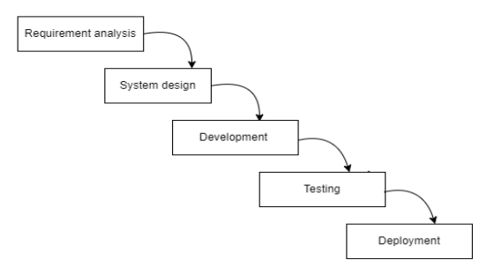

Figure 3.1 Waterfall Model of

Figure 3.1 Online Job Portal

3.1.1 Requirement Analysis
There are two types of requirement analysis:
- Functional Requirements

Job seekers
- Job seekers can register and log in to the system.
- Job seekers can look at the job description.
- Job seekers can message employers for information.
- Job seekers can apply for suitable jobs.
- Job seekers can upload their CVs.
- Job seekers can log out from the system.

Employer
- Employers can add and delete jobs.
- Employers can see the registered users.
- Employers can view users who applied for jobs and their CVs.

Admin
- Admin can manage user info.
- Admin can manage job info and website.

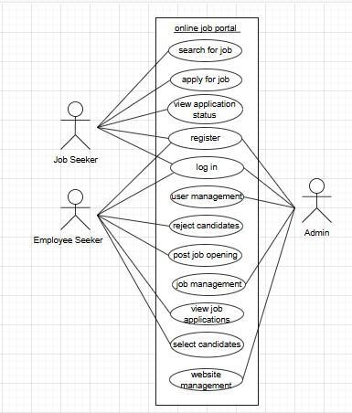

Figure 3.2 Use Case Diagram

ii. Non-Functional Requirements
- Security: This system is secure and the user’s information won’t be available for others for user privacy.
- Reliability: It will be reliable for the user.

3.1.2 Feasibility Analysis
- Technical feasibility: The project will be technically feasible because it will be implementable using the latest hardware and software readily available in the market. The developer will possess the required technical expertise to develop and maintain the platform.
The following software is used for the development of the system
- Vs code
- MySQL
- Apache[xampp]
And windows 10 is used as operating system as it is faster and reliable than other operating system.

- Operational feasibility:
The platform is easily integrated. It is accessible using any smart devices that support browsers, and its user interface is easy to navigate, making it user-friendly for both users and admins.

- Economic feasibility:
Before the development of the system, the proposed system should study whether the system is budget friendly or not. The project we are developing is within the cost estimation of the organization. The system development does not required expensive hardware and software. Hence, the project is said to be economically feasibility.

- Schedule feasibility:
The system will complete within scheduled time and is not exceeding the schedule time.

START DATE:2024-8-15 END DATE:2025-02-14
Phase/Week | 1st-2nd Week |  | 3rd-4th Week |  | 5th-8th  Week |  |  |  | 9th- 12th  Week |  |  |  | Last Week
Planning
Analysis
Design
Implementation
Testing
Documentation
Figure 3.3 Gantt Chart

3.1.3 Data Modeling(ER-Diagram)
An Entity-Relationship (ER) diagram is a visual representation of the data model for a database system.
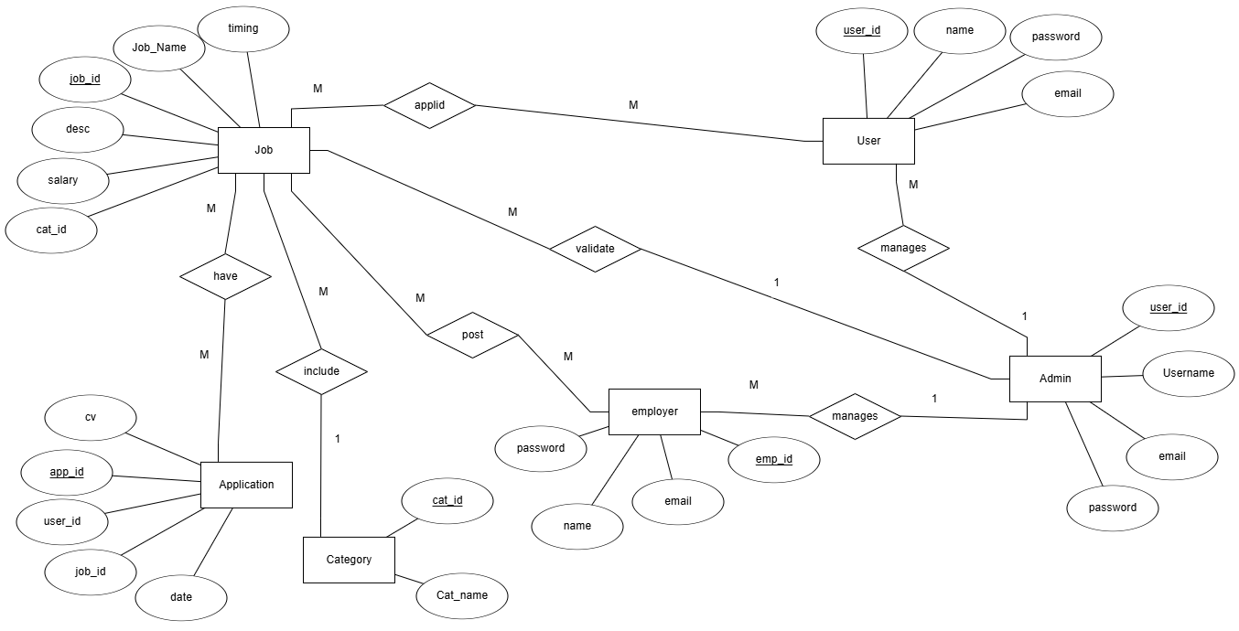
Figure 3.4 ER- Diagram of Online Job Portal

3.1.4 Process Modeling (DFD)
In context diagram, the online job portal is at the center of the diagram. There are two external entities which are Admin and User that interact with the system. Users request for login, view job, manage their account, add job, on the other hand Admin logins and manages the employee, users and job. These diagrams provide a high-level overview of the data flow and interactions within the system from both the user and admin perspectives.

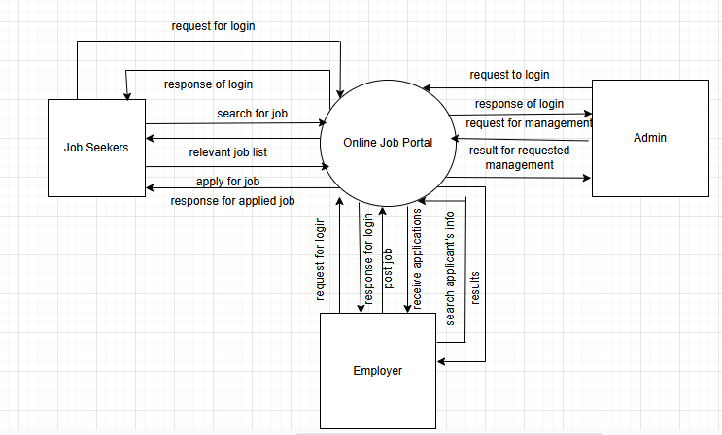
Figure 3.5 Context Level Diagram of Online Job Portal

A Level 1 Data Flow Diagram (DFD) is the next level of decomposition after the contextlevel diagram. It breaks down the high-level processes in the context-level diagram into more detailed sub-processes, showing the data flows between them. Level 1 DFD provides a more comprehensive view of the system's functionality, helping to understand the data flow and processing within the system.
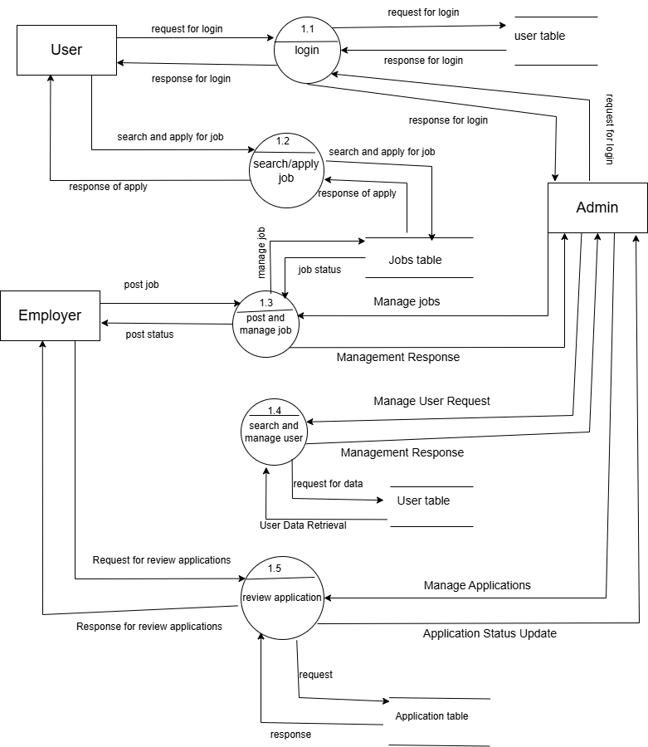

Figure 3.6 Level 1 DFD of Online Job Portal

3.2 System Design
System design is the process of defining the architecture, components, and functionality of a software system. It involves creating detailed specifications, diagrams, and plans that outline how the system will be built and function. The Online Job Portal is designed using various schema design, CASE tools and is described using following designs.

3.2.1 Architecture Design
Architecture design is the process of creating a blueprint for a software system, outlining its structure, components and interactions. It defines the system’s overall organization, to make sure it meets the functional and non-functional requirements. Architecture design serve as the foundation for the development and implementation of the software.

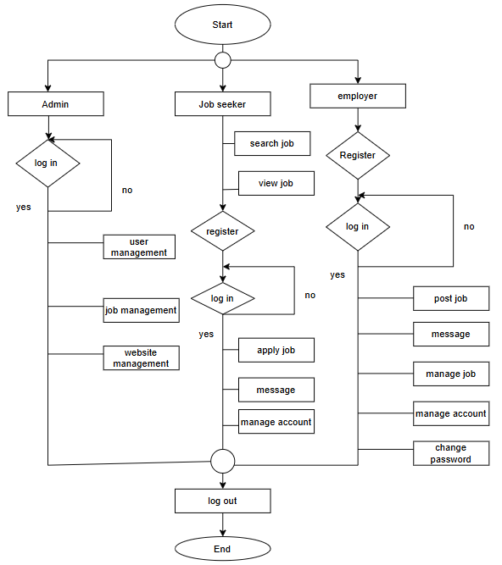
Figure 3.7 Flow Chart of Online Job Portal

3.2.2 Database Schema Design
Database schema design organizes the data into separate entities, determines how to create relationships between organized entities, and how to apply the constraints on the data. In the figure below, there are four tables in the database each of them has their own fields and identified with their respective primary key which is used in another table, becomes a foreign key. The fields in each entity table have data type according to the data it stores. The cardinality is shown by the arrows as shown in the diagram:

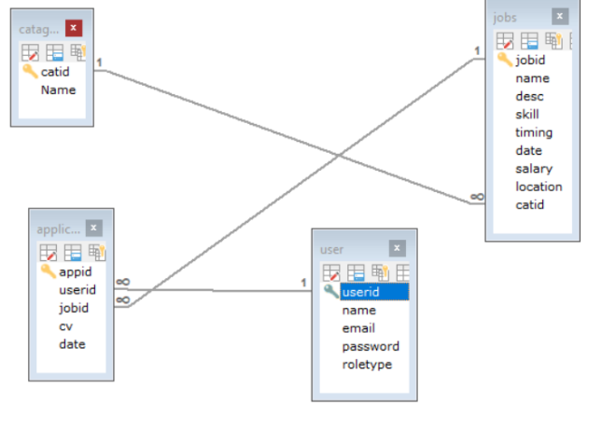

Figure 3.8 Database Schema Design

3.2.3 Interface Design
User interface is what a user sees in the website in simple terms. It is the way for end-user to access the respective panels like employer panel or admin panel used to interact with the system. It is used to build interfaces of the system focusing on overall look and feel of the proposed system. We tried our best to design easy to use user interface for the employer, job seeker and admin. The following are the UI designs of the system.

Login page of Online Job Portal
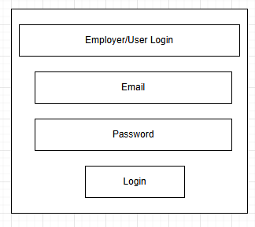

Figure 3.9 Employer/User Login Page

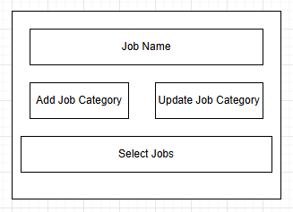
Selecting Category Page

Figure 3.10 Category Page

Job Search Page
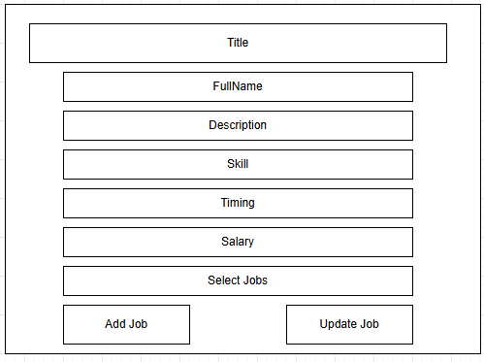

Figure 3.11 Job Search Page

3.2.4 Physical DFD
A Physical Data Flow Diagram (DFD) provides a detailed view of the actual implementation of system, depicting how data flows between physical components and processes. It represents external entities as hardware or software components, processes as specific software modules or physical devices, and data stores as databases or storage devices. Physical DFDs are used during system implementation to identify hardware and software requirements, plan system architecture, and understand how data is processed and stored in the real world. They offer a technical perspective, aiding in integration planning and facilitating communication between developers, system analysts, and stakeholders.

CHAPTER 4 IMPLEMENTATION AND TESTING

- Implementation
In this phase, theoretical design is turned into practical working system. The most crucial stage in achieving a new successful system and in giving confidence on the new system for the users that it will work efficiently and effectively.

The system can be implemented only after thorough testing is done and if it is found to work according to the specification.

4.1.1 Tools Used
- Front-End Tools
- HTML: This is used to create web pages.
- CSS: This is used to design web pages.
- JavaScript: This is used to create interactive web page.

- Back-End Tools
- PHP: This is used to create web pages.
- XAMPP: This is used to host this project.
- MySQL: This is used to managing a data for this project to generate dynamic content.

- CASE Tools
- VS Code: This is a lightweight code editor used to writing a code for this project.
- MS Word: This is used for documentation for this project.

4.1.2 Implementation Details of Modules
Different modules of this system are described as below:
Admin Module:
- Authentication Module:
- This module handles admin login and authentication.
- It verifies admin credentials and grants access to the admin dashboard upon successful authentication.

- Job Management Module:
- This module allows admins to view, create, edit, and delete jobs.

- Employer/User Management Module:
- Admins can manage employer accounts through this module.
- They can view a list of registered users, search for specific users, and perform actions such as suspending or deleting accounts.

Employer Module:
- Authentication Module:
- Similar to the admin module, this module handles employer login and authentication.
- It verifies employer credentials and grants access to employer-specific functionalities upon successful authentication.

- Job Posting and Management Module:
- It manage job listings and update them as necessary.

Job Seeker Module:
- Authentication Module:
- This module handle job seeker profile creation.
- It helps to search jobs interface with filters, upload resume etc.

- Purpose Module
- It allow job seekers to manage their profile, search for jobs, and apply.

4.2 Testing
4.2.1 User Registration Testing
S.N | Input  Email Password  Name | Expected Output | Actual  Output | Test Result
1 | Anisha Khatiwada ----------- - anisha@1 | Fail | Fail | Success
2 | Sima Malla mallasima@ sima@2  gmail.com | Pass | Pass | Success

4.2.2 User Login Testing
S.N | Input  Username Password | Expected Output | Actual  Output | Test Result
1 | ---------------- anisha@1 | Fail | Fail | Success
2 | mallasima sima@2 | Pass | Pass | Success

4.2.3 System Testing
Test Id | Test Scenario | Test Data | Expected Result | Actual Result | Test Result
T1 | Register | FirstName, LastName, Email, password | Successfully Register | Pass | Success
T2 | Login | Email, Password | Successfully login | Pass | Success
T3 | Add Job | Add or update job | Added job | Pass | Success
T4 | Apply Job | Select or apply job | Applied job | Pass | Success
T5 | Manage Job | Create, delete or update job | Managed job | Pass | Success

CHAPTER 5
CONCLUSION AND FUTURE RECOMMENDATION

- Lesson learnt/Outcome
After developing and implementing Online Job Portal site there are various lesson that we figure out and learnt like:
- Learn how to do system analysis and feasibility study.
- Learn full cycle of development process.
- Learnt to integrate the system UI with database.

- Conclusion
After the completion of the online job portal website, people can perform easy apply for the suitable job through online. The current website has fulfilled all the objectives. We followed the specifications strictly but enhanced some of the features when there was need for it to be done. There have been specially challenging when it comes to backend and making sure that the website responses in a predictable manner.

As we came to the end of the project, we realized that there are many enhancements that can be made on the website. Some of the ideas came from those who tested the website and some of them from both of us.

- Future Recommendation
Here is what we can add in the future on this website to increase its usability, user experience and portability of the website. There is a lot to be done hence this website can be considered as a starting point for something big to come. It will need more time and
Addition of location wise filters.

Addition of online interview of selected candidate.

Addition of AI –driven job matching.

References

[1] | A.Khan, "Intellipaad," [Online]. Available: https://www.intellipaad.com. [Accessed 13 December 2024].
[2] | G. Mithun, "A Report on Job Portal," vol. 6, no. 2019, p. 8, 2020.
[3] | "SlideShare," vol. 6, no. 2019, p. 09, 2022.
[4] | "Studoc," [Online]. Available: https://www.studoc.com. [Accessed 15 December 2024].
[5] | M. Khan, "Online Job Portal," 2015. [Online]. [Accessed 15 December 2024].
[6] | Toolsqa, 12 January 2019. [Online]. Available: https://www.toolsqa/software-testing/waterfall-model. [Accessed December 2024].
[7] | "ResearchGate," Online Job Portal, vol. 16, p. 10, January 2024.

APPENDICES

Home Page of Online Job Portal

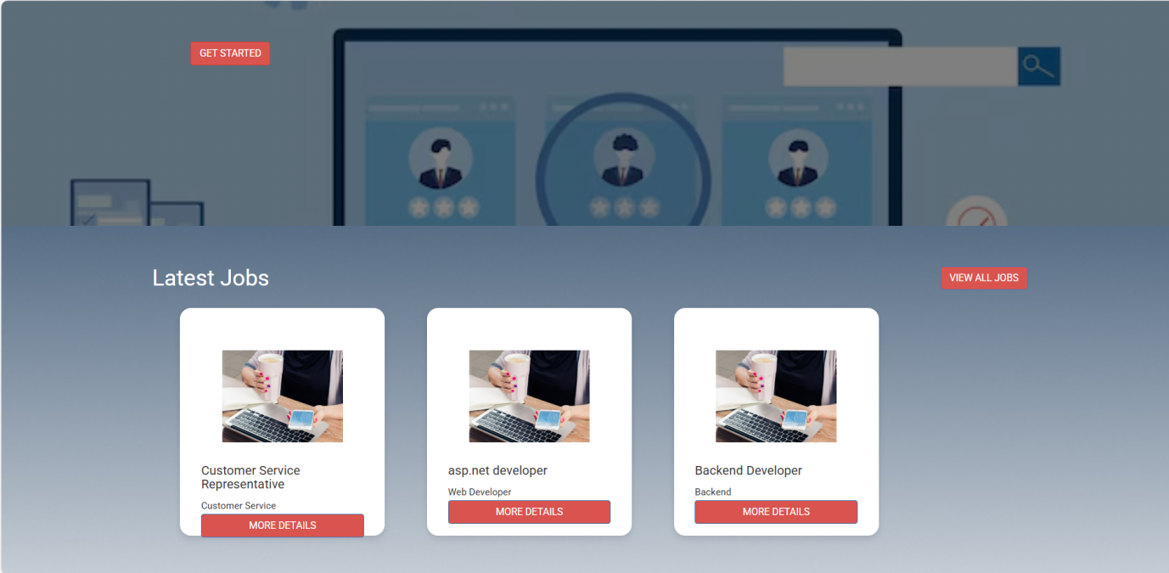
Latest Jobs

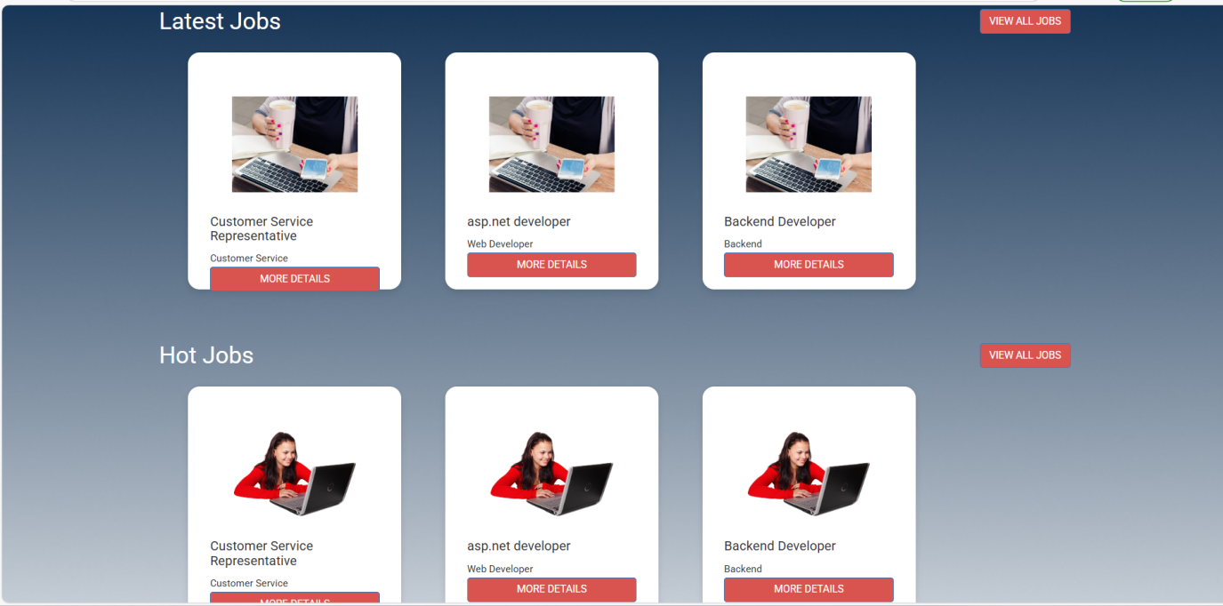
Top Jobs

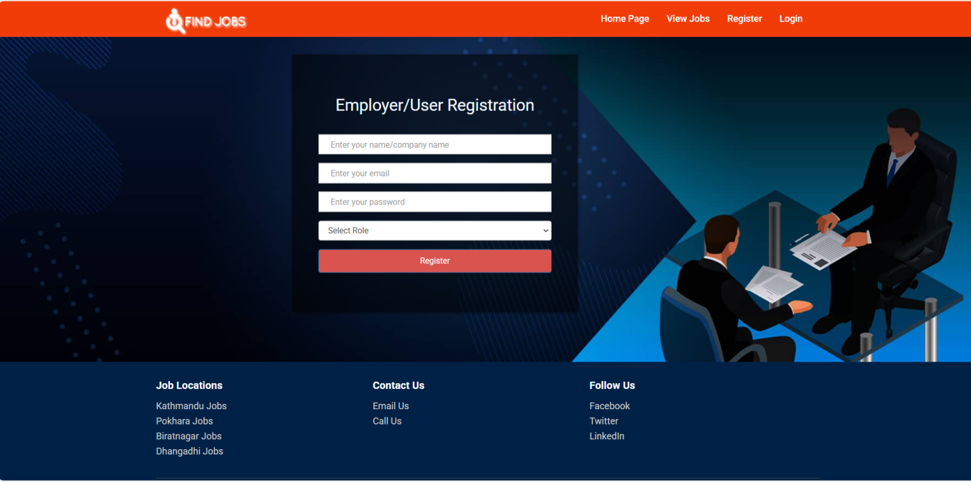
Employee/User Register Page

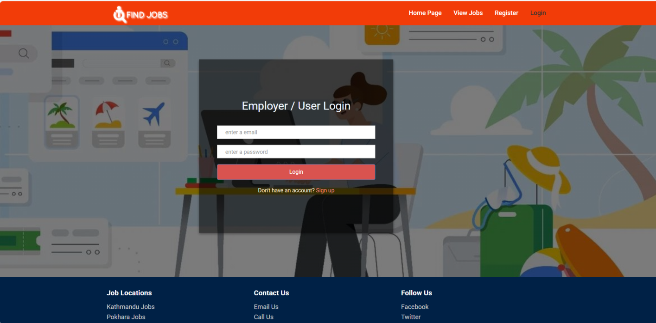
Employer/User Login Page

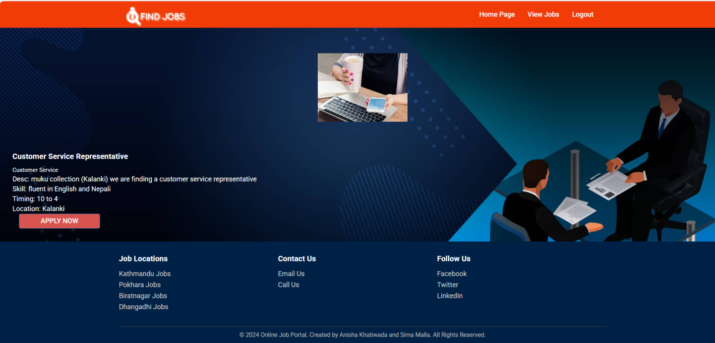
Job Apply Page

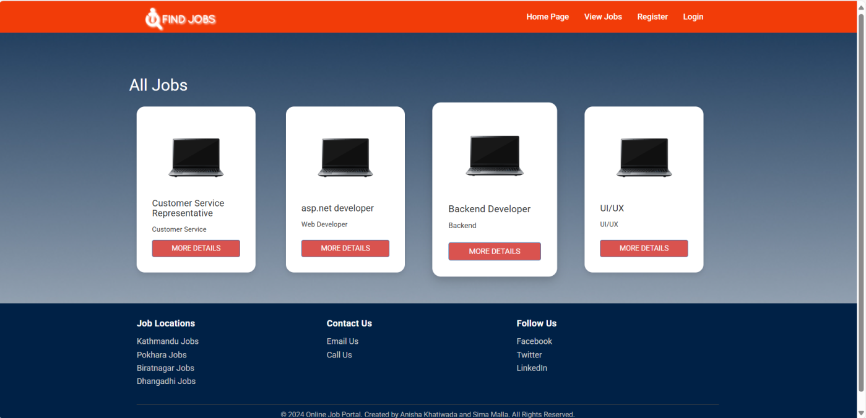
View Jobs

